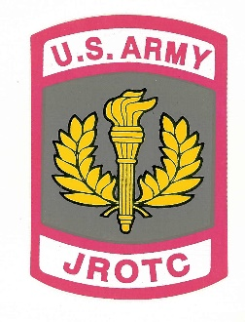

LCLHS-JROTC

Memorandum of Information

SUBJECT: JROTC Events and Activities

Parent/Guardian-Cadet

TEAMS AND ACTIVITIES

The Laney JROTC Program will be conducting extra-curriculum activities and events after school to enable the cadets to be involved and participative in the JROTC Program. The after school events and activities are on a volunteer basis and will include Leadership meetings (Tues only), drill team, color guard, raider team, rifle team, academic team, and special teams. The team practices will be on Tuesday thru Thursday beginning at 3:00 pm to NLT 4:30 pm. Team practice days will be scheduled by the Team Captains. All team members must be present for that event/activity on time to receive credit for that event and to continue to be a member of the team. The teams are open to all Cadets and are highly encouraged to participate. Cadets will receive awards, certificates, and recognition for participating in JROTC events/activities. Mandatory events will include formal events, Parades and Ceremonies.

UNIFORMS

Cadets are required to wear the JROTC uniform once a week in accordance with Cadet Command Regulations. Cadets will be required to wear the uniform on Wednesdays. Cadets are required to wear the uniform all day to receive credit/grade for this event. Cadets are allowed a make-up day by wearing the uniform the following day with a valid absence or excuse.

Cadets will be involved in Community Outreach Services, Service Learning Projects, and local Field Trips. It is highly recommended that all Cadets apply themselves and attempt to get involved in the JROTC experience. Involved Cadets are able to achieve and excel in all aspects of their high school tenure, these Cadets are labeled productive cadets. Non-productive cadets normally miss out on the opportunities and benefits the JROTC Program have to offer.

Step up to the Challenge,

JROTC Instructors